## Reports/Daily Reports /Log Copy Label status Detailed report

Request:

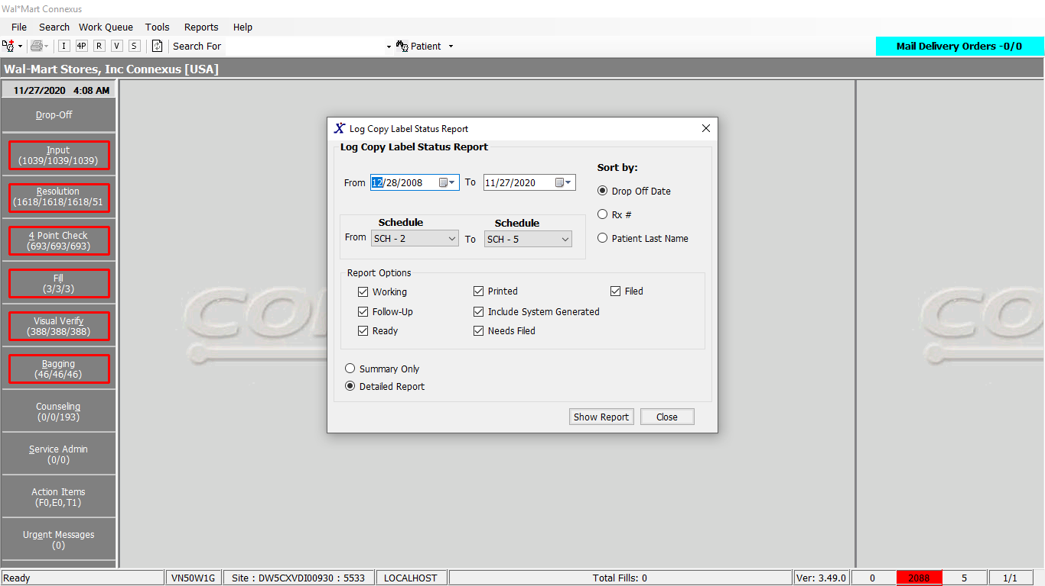

Response:

Detailed report:

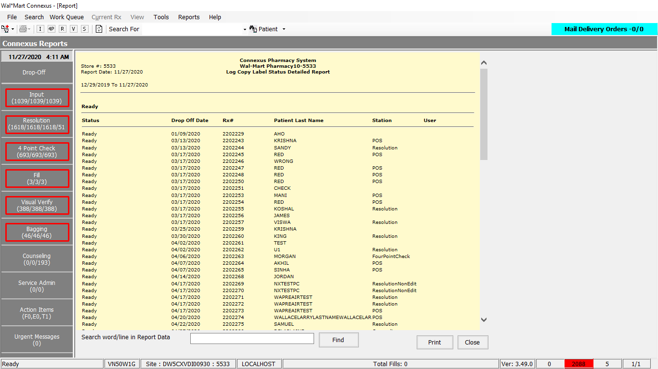

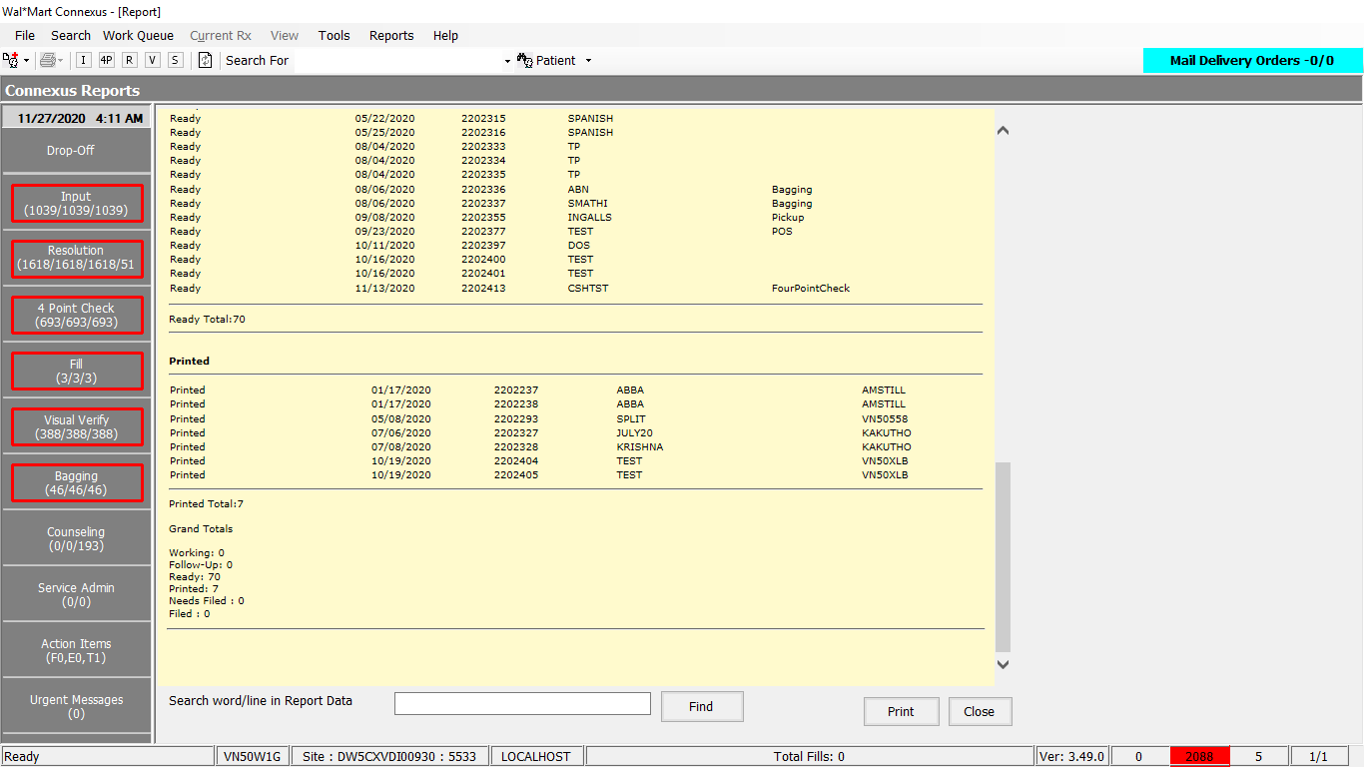

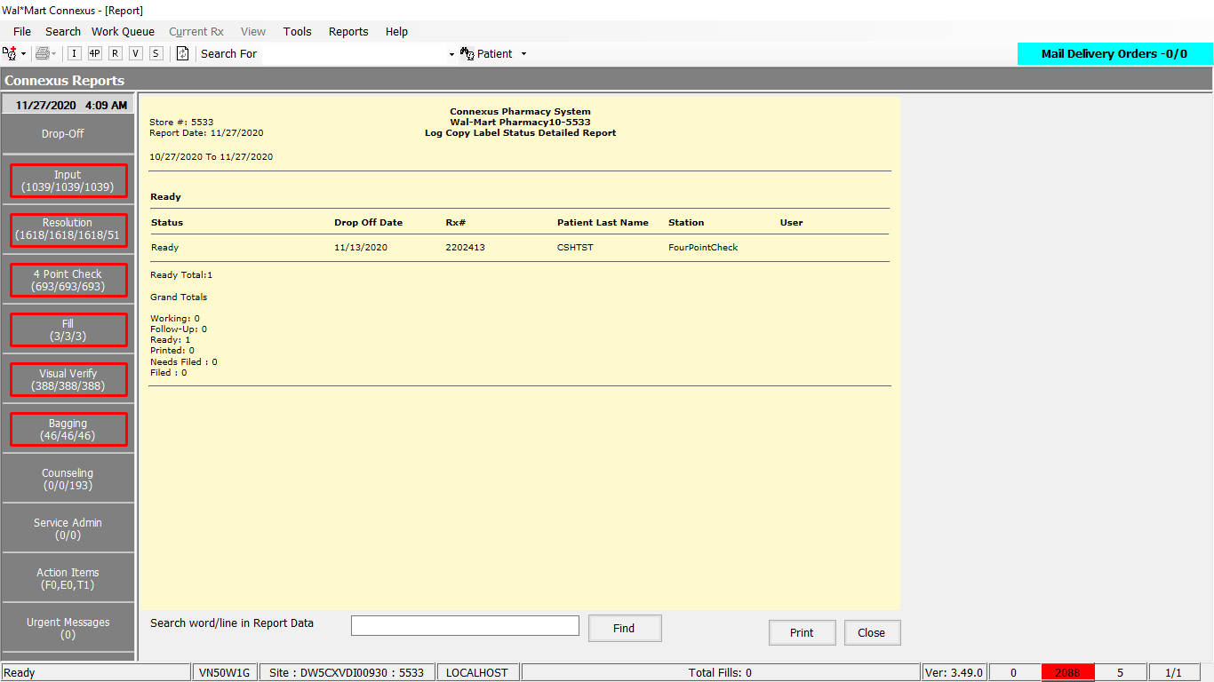

Summary report:

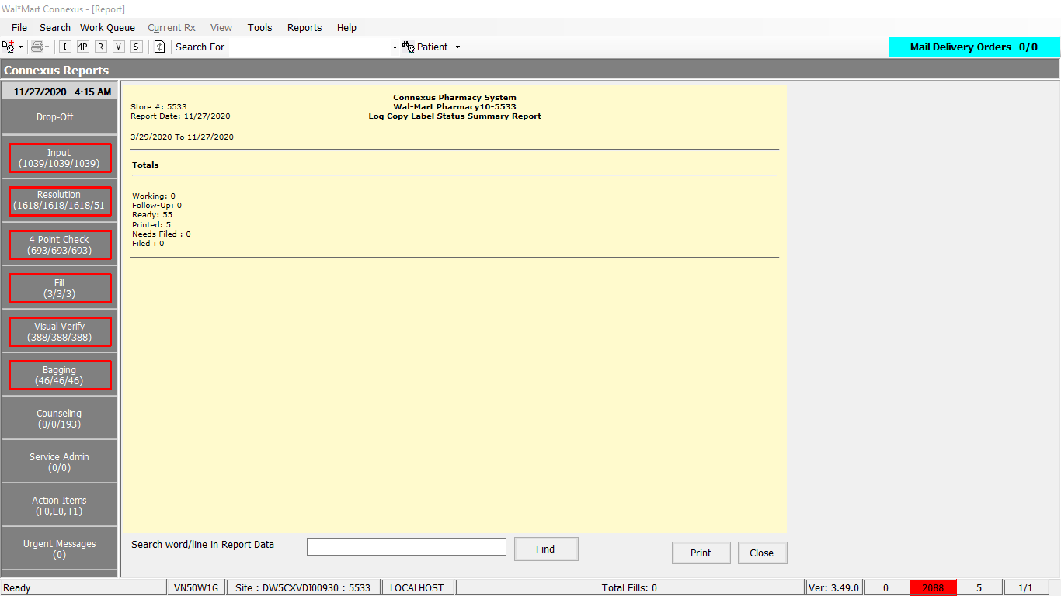

Query:

1. Friend Const GetLogCopyStatusDetailReport1 As String = "" &

" SELECT " &

" rx.rx_nbr, " &

" eod.rx_eod_status_cd, " &

" rxdetail.next_work_que_code, " &

" p.last_name, " &

" rx.version_seq_nbr_ts, " &

" rxact.activity_userid, " &

" rxact.activity_seq_nbr " &

" FROM rx_end_of_day_image eod, " &

" patient p, " &

" pharmacy_offering:pharmacy_product pp, " &

" rx, " &

" OUTER rx_activity rxact, " &

" OUTER rx_order_detail rxdetail " &

" WHERE eod.rx_id = rx.rx_id " &

" AND eod.rx_version_seq_nbr = rx.rx_version_seq_nbr " &

" AND rx.patient_id = p.patient_id " &

" AND rxact.rx_id = rx.rx_id " &

" AND rxact.rx_version_seq_nbr = rx.rx_version_seq_nbr " &

" AND rxdetail.rx_id = rx.rx_id " &

" AND rxdetail.rx_version_seq_nbr = rx.rx_version_seq_nbr " &

" AND rx.version_seq_nbr_ts BETWEEN ? AND ? " &

" AND rxact.activity_ts >= ? " &

" AND rxact.activity_code between 32659 AND ? " &

" AND pp.drug_control_code between ? AND ? " &

" AND pp.product_mds_fam_id = rx.product_mds_fam_id " &

" AND rx.compound_ind = 'N' "

2. Friend Const GetLogCopyStatusDetailReport2 As String = "" &

" UNION " &

" SELECT " &

" rx.rx_nbr, " &

" eod.rx_eod_status_cd, " &

" rxdetail.next_work_que_code, " &

" p.last_name, " &

" rx.version_seq_nbr_ts, " &

" rxact.activity_userid, " &

" rxact.activity_seq_nbr " &

" FROM rx_end_of_day_image eod, " &

" patient p, " &

" pharmacy_offering:pharmacy_product pp, " &

" rx, " &

" rx_compound rc, " &

" compound_product cp, " &

" OUTER rx_activity rxact, " &

" OUTER rx_order_detail rxdetail " &

" WHERE eod.rx_id = rx.rx_id " &

" AND eod.rx_version_seq_nbr = rx.rx_version_seq_nbr " &

" AND rx.patient_id = p.patient_id " &

" AND rxact.rx_id = rx.rx_id " &

" AND rxact.rx_version_seq_nbr = rx.rx_version_seq_nbr " &

" AND rxdetail.rx_id = rx.rx_id " &

" AND rxdetail.rx_version_seq_nbr = rx.rx_version_seq_nbr " &

" AND rx.version_seq_nbr_ts BETWEEN ? AND ? " &

" AND rxact.activity_ts >= ? " &

" AND rxact.activity_code between 32659 AND ? " &

" AND pp.drug_control_code between ? AND ? " &

" AND pp.product_mds_fam_id = cp.mds_fam_id " &

" AND rc.rx_id = rx.rx_id " &

" AND rc.compound_id = cp.compound_id " &

" AND pp.product_mds_fam_id = cp.mds_fam_id " &

" AND rx.compound_ind = 'Y' " &

" GROUP BY " &

" rx.rx_nbr, " &

" eod.rx_eod_status_cd, " &

" rxdetail.next_work_que_code, " &

" p.last_name, " &

" rx.version_seq_nbr_ts, " &

" rxact.activity_userid, " &

" rxact.activity_seq_nbr " &

" HAVING MIN(drug_control_code) between ? AND ? "

3. Friend Const GetLogCopyStatusDetailReport3 As String = " ORDER BY 2,"

4.Friend Const GetLogCopyStatusSummaryReport1 As String = "" &

" SELECT " &

" eod.rx_eod_status_cd, " &

" rx.rx_nbr " &

" FROM rx_end_of_day_image eod, " &

" patient p, " &

" pharmacy_offering:pharmacy_product pp, " &

" rx, " &

" OUTER rx_activity rxact, " &

" OUTER rx_order_detail rxdetail " &

" WHERE eod.rx_id = rx.rx_id " &

" AND eod.rx_version_seq_nbr = rx.rx_version_seq_nbr " &

" AND rx.patient_id = p.patient_id " &

" AND rxact.rx_id = rx.rx_id " &

" AND rxact.rx_version_seq_nbr = rx.rx_version_seq_nbr " &

" AND rxdetail.rx_id = rx.rx_id " &

" AND rxdetail.rx_version_seq_nbr = rx.rx_version_seq_nbr " &

" AND rx.version_seq_nbr_ts BETWEEN ? AND ? " &

" AND rxact.activity_ts >= ? " &

" AND rxact.activity_code between 32659 AND ? " &

" AND pp.drug_control_code between ? AND ? " &

" AND pp.product_mds_fam_id = rx.product_mds_fam_id " &

" AND rx.compound_ind = 'N' "

5. Friend Const GetLogCopyStatusSummaryReport2 As String = "" &

" UNION " &

" SELECT " &

" eod.rx_eod_status_cd, " &

" rx.rx_nbr " &

" FROM rx_end_of_day_image eod, " &

" patient p, " &

" pharmacy_offering:pharmacy_product pp, " &

" rx, " &

" rx_compound rc, " &

" compound_product cp, " &

" OUTER rx_activity rxact, " &

" OUTER rx_order_detail rxdetail " &

" WHERE eod.rx_id = rx.rx_id " &

" AND eod.rx_version_seq_nbr = rx.rx_version_seq_nbr " &

" AND rx.patient_id = p.patient_id " &

" AND rxact.rx_id = rx.rx_id " &

" AND rxact.rx_version_seq_nbr = rx.rx_version_seq_nbr " &

" AND rxdetail.rx_id = rx.rx_id " &

" AND rxdetail.rx_version_seq_nbr = rx.rx_version_seq_nbr " &

" AND rx.version_seq_nbr_ts BETWEEN ? AND ? " &

" AND rxact.activity_ts >= ? " &

" AND rxact.activity_code between 32659 AND ? " &

" AND pp.drug_control_code between ? AND ? " &

" AND pp.product_mds_fam_id = cp.mds_fam_id " &

" AND rc.rx_id = rx.rx_id " &

" AND rc.compound_id = cp.compound_id " &

" AND pp.product_mds_fam_id = cp.mds_fam_id " &

" AND rx.compound_ind = 'Y' " &

" GROUP BY " &

" rx.rx_nbr, " &

" eod.rx_eod_status_cd, " &

" rxdetail.next_work_que_code, " &

" p.last_name, " &

" rx.version_seq_nbr_ts, " &

" rxact.activity_userid, " &

" rxact.activity_seq_nbr " &

" HAVING MIN(drug_control_code) between ? AND ? "

6. Friend Const GetLogCopyStatusSummaryReport3 As String = " ORDER BY 1, 2"

DAL:

1. Public Function GetLogCopyStatusDetailReport(ByVal siteId As Integer, ByVal fromDate As Date,

ByVal toDate As Date, ByVal fromSchedule As Integer,

ByVal toSchedule As Integer, ByVal sortOption As Integer, ByVal include As String,

ByVal includeSysGen As Boolean) _

As List(Of LogCopyStatusDetailBE) Implements IReportDAL.GetLogCopyStatusDetailReport

Dim getLogCopyStatusDetailList As New List(Of LogCopyStatusDetailBE)

Dim getLogCopyStatusDetail As LogCopyStatusDetailBE = Nothing

Dim sqlString As New StringBuilder

' 01/17/2012 i2chauh: SQL Tuning for Log copy detail report.

' Passing To-datetime with value (example: 01/31/2012 23:59:59)

Dim toDateTime As DateTime

toDateTime = toDate.AddDays(1).AddSeconds(-1)

Dim toActivityCode As Integer

Dim previousRxNbr As Integer = 0

' 01/17/2012 i2chauh: Compound component query of first UNION select

sqlString.Append(ReportQueries.GetLogCopyStatusDetailReport1)

If Not String.IsNullOrEmpty(include) Then

sqlString.Append(" AND eod.rx_eod_status_cd in ( " & include)

sqlString.Append(" )")

Else

Return Nothing

End If

' 01/17/2012 i2chauh: SQL Tuning for Log copy detail report.

' Compound component query of second UNION select

sqlString.Append(ReportQueries.GetLogCopyStatusDetailReport2)

sqlString.Append(" AND eod.rx_eod_status_cd in ( " & include)

sqlString.Append(" )")

' 01/17/2012 i2chauh: SQL Tuning for Log copy detail report. Added it as parameter list.

If Not includeSysGen Then

toActivityCode = 32659

Else

toActivityCode = 32660

End If

' 01/17/2012 i2chauh: ORDER BY clause

sqlString.Append(ReportQueries.GetLogCopyStatusDetailReport3)

If sortOption = ConnexusCommonConstants.SortByDropOffDate Then

sqlString.Append(" 5") 'version_seq_nbr_ts

ElseIf sortOption = ConnexusCommonConstants.SortByRxNbr Then

sqlString.Append(" 1") 'rx_nbr

ElseIf sortOption = ConnexusCommonConstants.SortByPatientLastName Then

sqlString.Append(" 4") 'Last_name

End If

' 01/17/2012 i2chauh: SQL Tuning for Log copy detail report.

' If rx_activity has multiple records for same RxNbr, pick the latest one

' Logic is below after result set is fetched

sqlString.Append(" , 1, 7 DESC")

Dim paramList As New List(Of DbParameter)

paramList.Add(ParameterHelper.BuildParameter("fromDate", DbType.DateTime, fromDate))

paramList.Add(ParameterHelper.BuildParameter("toDate", DbType.DateTime, toDateTime))

paramList.Add(ParameterHelper.BuildParameter("fromDate", DbType.DateTime, fromDate))

paramList.Add(ParameterHelper.BuildParameter("toActivityCode", DbType.Int32, toActivityCode))

If fromSchedule > toSchedule Then

paramList.Add(ParameterHelper.BuildParameter("fromSchedule", DbType.Int32, toSchedule))

paramList.Add(ParameterHelper.BuildParameter("toSchedule", DbType.Int32, fromSchedule))

Else

paramList.Add(ParameterHelper.BuildParameter("fromSchedule", DbType.Int32, fromSchedule))

paramList.Add(ParameterHelper.BuildParameter("toSchedule", DbType.Int32, toSchedule))

End If

' 01/17/2012 i2chauh: SQL Tuning for Log copy detail report. Added more parameters to the list

paramList.Add(ParameterHelper.BuildParameter("fromDate", DbType.DateTime, fromDate))

paramList.Add(ParameterHelper.BuildParameter("toDate", DbType.DateTime, toDateTime))

paramList.Add(ParameterHelper.BuildParameter("fromDate", DbType.DateTime, fromDate))

paramList.Add(ParameterHelper.BuildParameter("toActivityCode", DbType.Int32, toActivityCode))

If fromSchedule > toSchedule Then

paramList.Add(ParameterHelper.BuildParameter("fromSchedule", DbType.Int32, toSchedule))

paramList.Add(ParameterHelper.BuildParameter("toSchedule", DbType.Int32, fromSchedule))

paramList.Add(ParameterHelper.BuildParameter("fromSchedule", DbType.Int32, toSchedule))

paramList.Add(ParameterHelper.BuildParameter("toSchedule", DbType.Int32, fromSchedule))

Else

paramList.Add(ParameterHelper.BuildParameter("fromSchedule", DbType.Int32, fromSchedule))

paramList.Add(ParameterHelper.BuildParameter("toSchedule", DbType.Int32, toSchedule))

paramList.Add(ParameterHelper.BuildParameter("fromSchedule", DbType.Int32, fromSchedule))

paramList.Add(ParameterHelper.BuildParameter("toSchedule", DbType.Int32, toSchedule))

End If

Dim datareader As IDataReader = ExecuteReader(DatabaseEnum.rx21c, siteId, sqlString.ToString, paramList)

While datareader.Read

getLogCopyStatusDetail = New LogCopyStatusDetailBE

' 01/17/2012 i2chauh: SQL Tuning for Log copy detail report.

' If rx_activity has multiple records for same RxNbr, pick the latest one

If Not datareader.IsDBNull(datareader.GetOrdinal("rx_nbr")) Then

getLogCopyStatusDetail.RxNbr = CInt(datareader("rx_nbr"))

If getLogCopyStatusDetail.RxNbr.Equals(previousRxNbr) Then

Continue While

Else

previousRxNbr = getLogCopyStatusDetail.RxNbr

End If

End If

If Not datareader.IsDBNull(datareader.GetOrdinal("activity_userid")) Then

getLogCopyStatusDetail.ActivityUser = CStr(datareader("activity_userid")).Trim

End If

If Not datareader.IsDBNull(datareader.GetOrdinal("version_seq_nbr_ts")) Then

getLogCopyStatusDetail.DropOffDate = Convert.ToDateTime(datareader("version_seq_nbr_ts"))

End If

If Not datareader.IsDBNull(datareader.GetOrdinal("Last_name")) Then

getLogCopyStatusDetail.PatientLastName = CStr(datareader("Last_name"))

End If

If Not datareader.IsDBNull(datareader.GetOrdinal("rx_eod_status_cd")) Then

getLogCopyStatusDetail.Status = CInt(datareader("rx_eod_status_cd"))

End If

If Not datareader.IsDBNull(datareader.GetOrdinal("next_work_que_code")) Then

getLogCopyStatusDetail.ReasonOrStation = CStr(datareader("next_work_que_code"))

End If

getLogCopyStatusDetailList.Add(getLogCopyStatusDetail)

End While

If getLogCopyStatusDetailList.Count > 0 Then

Return getLogCopyStatusDetailList

Else

Return Nothing

End If

End Function

Public Function GetLogCopyStatusSummaryReport(ByVal siteId As Integer, ByVal fromDate As Date,

ByVal toDate As Date, ByVal fromSchedule As Integer,

ByVal toSchedule As Integer, ByVal sortOption As Integer, ByVal include As String,

ByVal includeSysGen As Boolean) _

As List(Of LogCopyStatusSummaryBE) Implements IReportDAL.GetLogCopyStatusSummaryReport

Dim getLogCopyStatusSummaryList As New List(Of LogCopyStatusSummaryBE)

Dim getLogCopyStatusSummary As LogCopyStatusSummaryBE = Nothing

Dim sqlString As New StringBuilder

' 01/17/2012 i2chauh: SQL Tuning for Log copy detail report.

' Passing To-datetime with value (example: 01/31/2012 23:59:59)

Dim toDateTime As DateTime

toDateTime = toDate.AddDays(1).AddSeconds(-1)

Dim toActivityCode As Integer

Dim prevActivityCode As Integer = -1

Dim previousRxNbr As Integer = 0

Dim statusCount As Integer = 0

' 01/17/2012 i2chauh: Compound component query of first UNION select

sqlString.Append(ReportQueries.GetLogCopyStatusSummaryReport1)

If Not String.IsNullOrEmpty(include) Then

sqlString.Append(" AND eod.rx_eod_status_cd in ( " & include)

sqlString.Append(" )")

Else

Return Nothing

End If

' 01/17/2012 i2chauh: SQL Tuning for Log copy detail report.

' Compound component query of second UNION select

sqlString.Append(ReportQueries.GetLogCopyStatusSummaryReport2)

sqlString.Append(" AND eod.rx_eod_status_cd in ( " & include)

sqlString.Append(" )")

' 01/17/2012 i2chauh: SQL Tuning for Log copy detail report. Added it as parameter list.

If Not includeSysGen Then

toActivityCode = 32659

Else

toActivityCode = 32660

End If

' 01/17/2012 i2chauh: ORDER BY clause

sqlString.Append(ReportQueries.GetLogCopyStatusSummaryReport3)

Dim paramList As New List(Of DbParameter)

paramList.Add(ParameterHelper.BuildParameter("fromDate", DbType.DateTime, fromDate))

paramList.Add(ParameterHelper.BuildParameter("toDate", DbType.DateTime, toDateTime))

paramList.Add(ParameterHelper.BuildParameter("fromDate", DbType.DateTime, fromDate))

paramList.Add(ParameterHelper.BuildParameter("toActivityCode", DbType.Int32, toActivityCode))

If fromSchedule > toSchedule Then

paramList.Add(ParameterHelper.BuildParameter("fromSchedule", DbType.Int32, toSchedule))

paramList.Add(ParameterHelper.BuildParameter("toSchedule", DbType.Int32, fromSchedule))

Else

paramList.Add(ParameterHelper.BuildParameter("fromSchedule", DbType.Int32, fromSchedule))

paramList.Add(ParameterHelper.BuildParameter("toSchedule", DbType.Int32, toSchedule))

End If

' 01/17/2012 i2chauh: SQL Tuning for Log copy detail report. Added more parameters to the list

paramList.Add(ParameterHelper.BuildParameter("fromDate", DbType.DateTime, fromDate))

paramList.Add(ParameterHelper.BuildParameter("toDate", DbType.DateTime, toDateTime))

paramList.Add(ParameterHelper.BuildParameter("fromDate", DbType.DateTime, fromDate))

paramList.Add(ParameterHelper.BuildParameter("toActivityCode", DbType.Int32, toActivityCode))

If fromSchedule > toSchedule Then

paramList.Add(ParameterHelper.BuildParameter("fromSchedule", DbType.Int32, toSchedule))

paramList.Add(ParameterHelper.BuildParameter("toSchedule", DbType.Int32, fromSchedule))

paramList.Add(ParameterHelper.BuildParameter("fromSchedule", DbType.Int32, toSchedule))

paramList.Add(ParameterHelper.BuildParameter("toSchedule", DbType.Int32, fromSchedule))

Else

paramList.Add(ParameterHelper.BuildParameter("fromSchedule", DbType.Int32, fromSchedule))

paramList.Add(ParameterHelper.BuildParameter("toSchedule", DbType.Int32, toSchedule))

paramList.Add(ParameterHelper.BuildParameter("fromSchedule", DbType.Int32, fromSchedule))

paramList.Add(ParameterHelper.BuildParameter("toSchedule", DbType.Int32, toSchedule))

End If

Dim datareader As IDataReader = ExecuteReader(DatabaseEnum.rx21c, siteId, sqlString.ToString, paramList)

' Result set from SQL is sorted on rx_eod_status_cd, rx_nbr

' The below logic counts how many distinct RXs are there for each status code

While datareader.Read

If Not datareader.IsDBNull(datareader.GetOrdinal("rx_eod_status_cd")) Then

If prevActivityCode.Equals(CInt(datareader("rx_eod_status_cd"))) Then

If Not datareader.IsDBNull(datareader.GetOrdinal("rx_nbr")) Then

If previousRxNbr.Equals(CInt(datareader("rx_nbr"))) Then

Continue While

Else

getLogCopyStatusSummary.StatusCount = getLogCopyStatusSummary.StatusCount + 1

previousRxNbr = CInt(datareader("rx_nbr"))

End If

End If

Else

If Not prevActivityCode.Equals(-1) Then

getLogCopyStatusSummaryList.Add(getLogCopyStatusSummary)

End If

getLogCopyStatusSummary = New LogCopyStatusSummaryBE

getLogCopyStatusSummary.RxEodStatusCode = CInt(datareader("rx_eod_status_cd"))

getLogCopyStatusSummary.StatusCount = 1

prevActivityCode = CInt(datareader("rx_eod_status_cd"))

End If

End If

End While

If getLogCopyStatusSummary IsNot Nothing Then

getLogCopyStatusSummaryList.Add(getLogCopyStatusSummary)

End If

If getLogCopyStatusSummaryList.Count > 0 Then

Return getLogCopyStatusSummaryList

Else

Return Nothing

End If

End Function